**Experiment-07**

**AIM: To develop PLC Ladder Program using Timer functions.**

**1)** Generate Square wave for Ton = 5sec & T off = 8sec using ladder diagram.

input :- START button(I:0.0/0)

:- STOP button(I:0.0/1)

output :- wave generator (O:0.0/0)

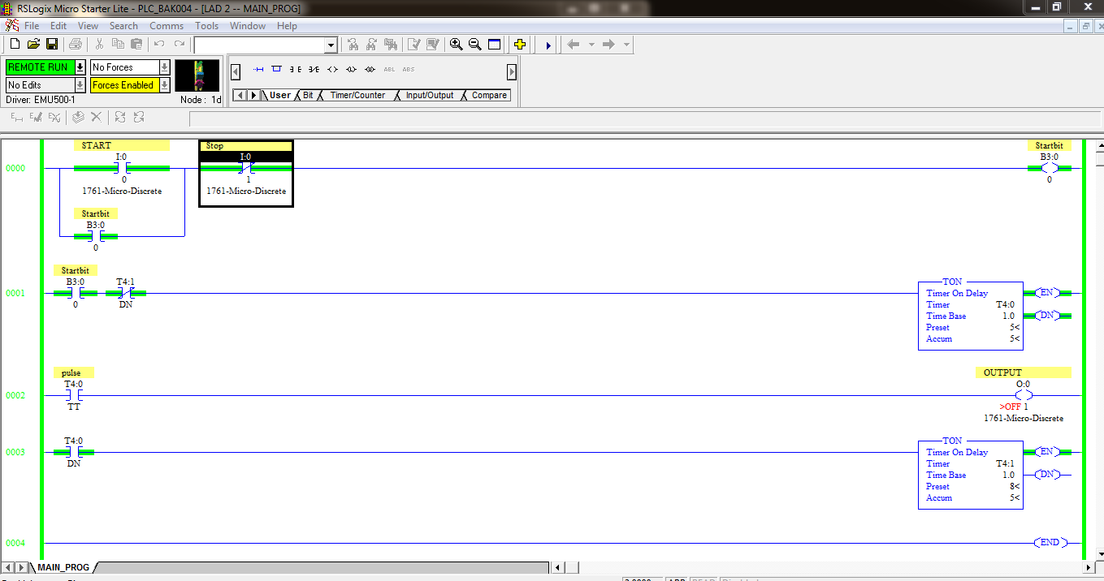

2) A wood saw, a fan F, W and a lubrication pump, P all go on when a start button is pushed. A stop button stops the saw only. The fan is to run 5sec additional to blow the chips away. The lube pump is to run for 8sec after shutdown of W. Additionally , if the saw has run more than one minute, the fan should stay on indefinitely. The fan may then be turned off by pushing a separate fan reset button. If the saw has run more than one minute, the pump should go off when the saw is turned off. The 8sec time delay off does not take place for a running time of less than 1 minute.

input :- 1) Start button (I:0.0/0)

2) System stop button (I:0.0/1)

3) Manual stop button for fan (M.S.F) (I:0.0/2)

4) stop button (I:0.0/3)

output :- 1) Wood cutter (O:0.0/0)

2) Fan (O:0.0/1)

3) Pump (O:0.0/2)

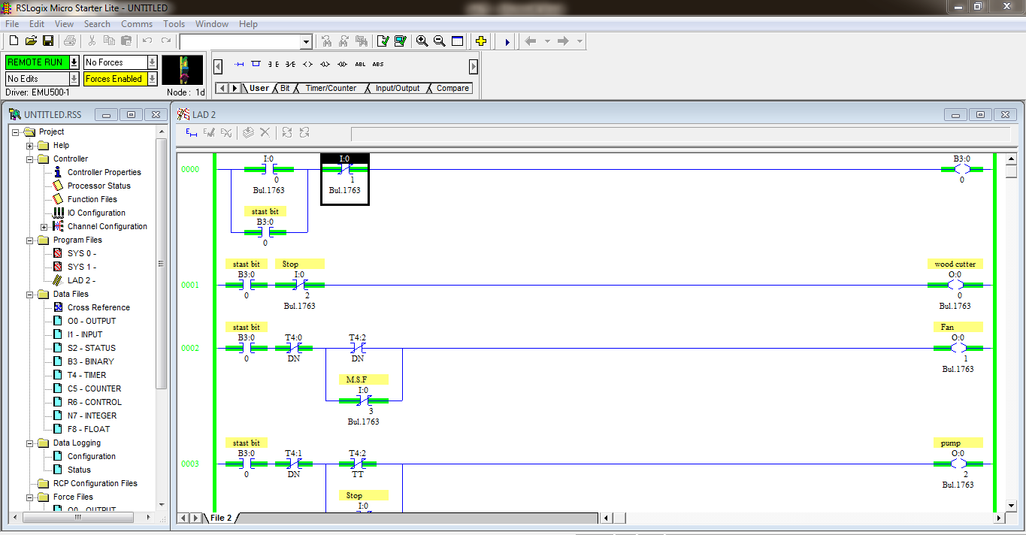

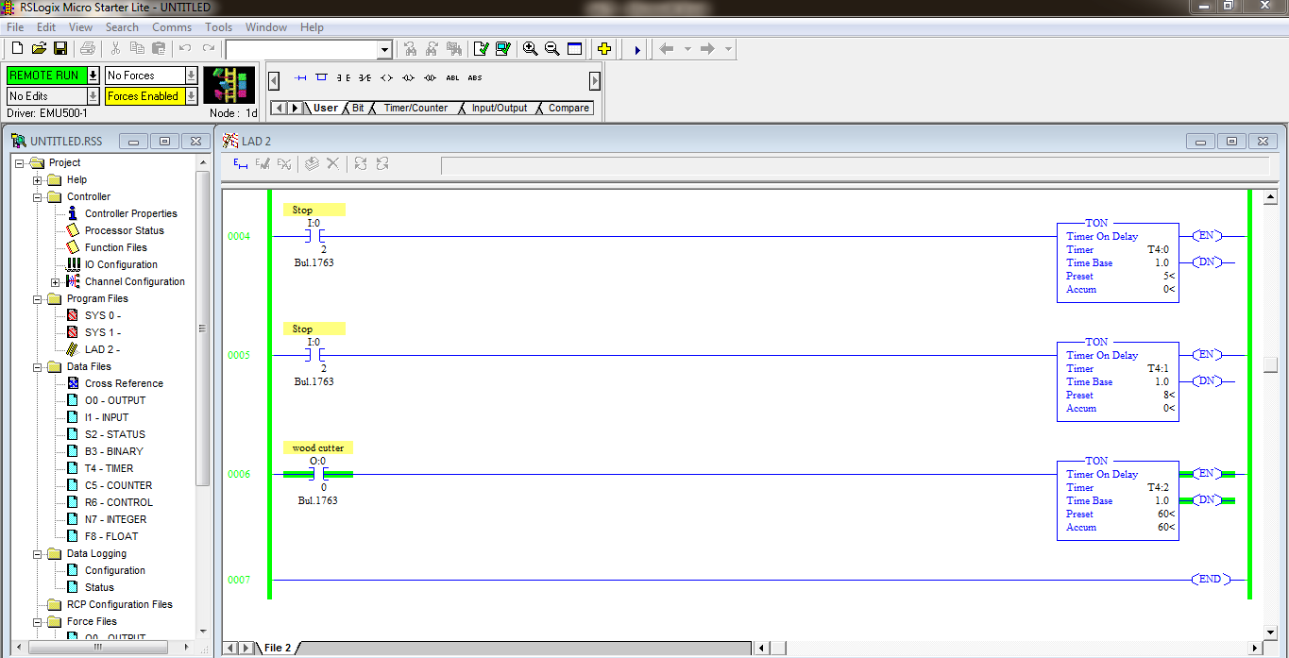

3) Write a programme to using ladder diagram to control a stepper motor so that it moves 10 step forward, waits for 20 seconds & further moves 10 steps. Then system should reset.

input :- 1) Start button – I:0.0/0

2) Stop button – I:0.0/1

Output :- 1) stepper motor – O:0.0/0

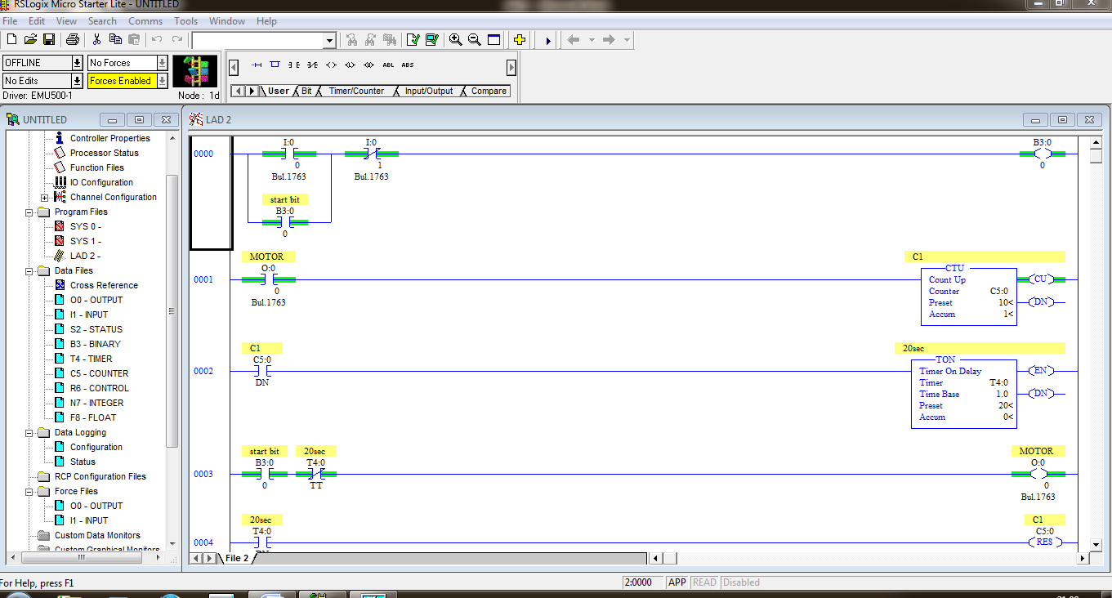

4) Write a programme using a ladder diagram to perform following actions

a) O/P B goes on at specific time after O/P A is turned on. When A is made off, B also goes off

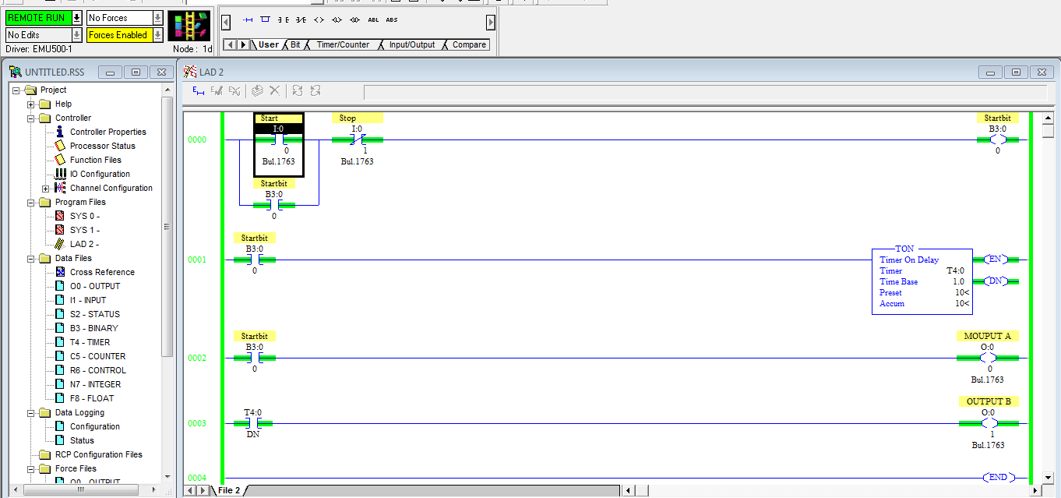

b) A & B start together. B goes off after some time but A remains ON.

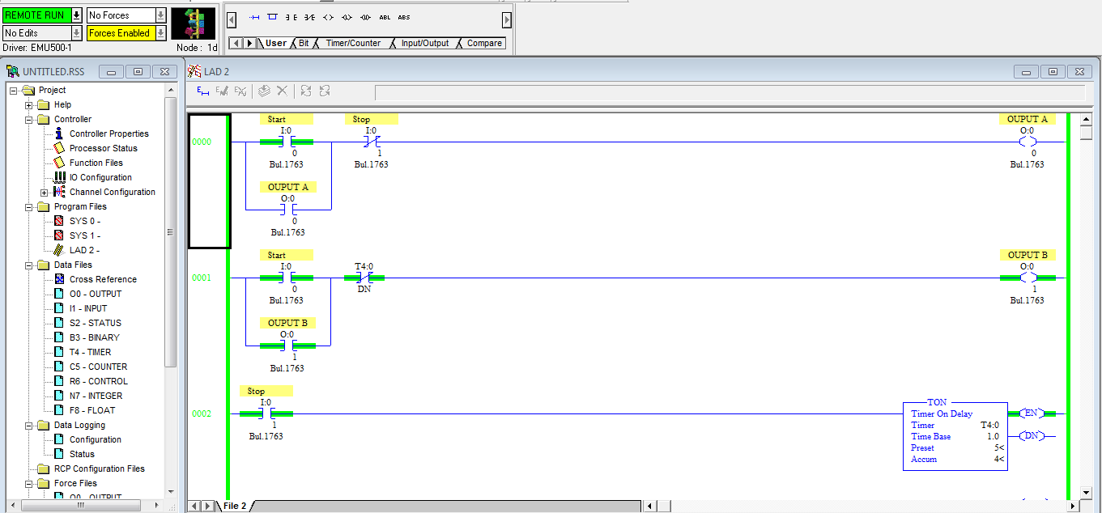

c)A & B start together.B goes off after some time but A remains ON.

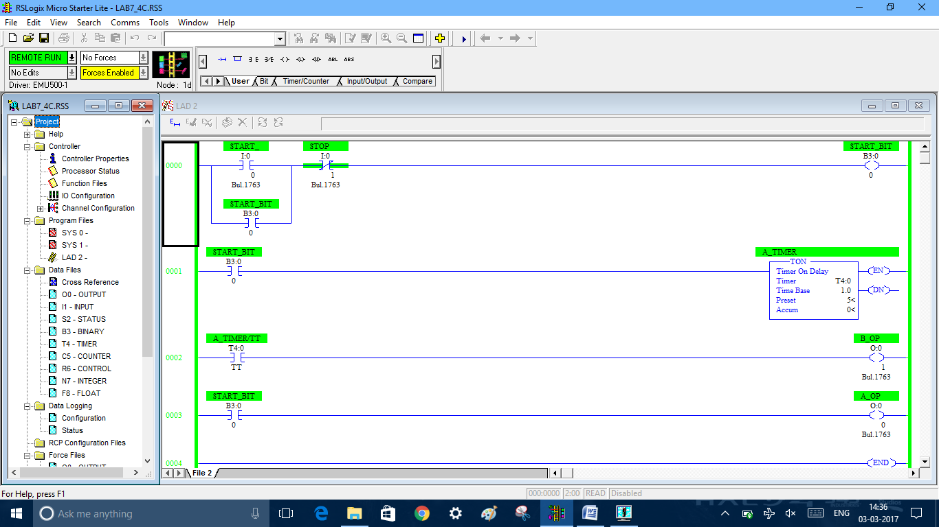

d) o/p pulse is on & quickly off at a preset time

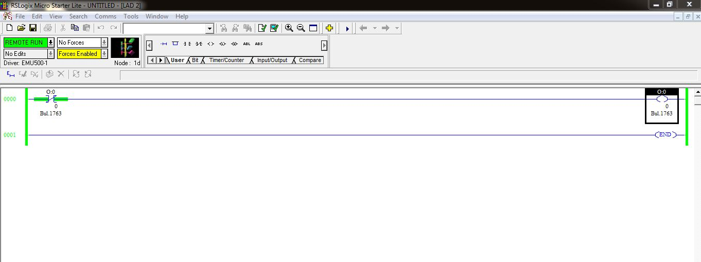

e) B is made on some time after A. B runs for its time period even if A is made off.

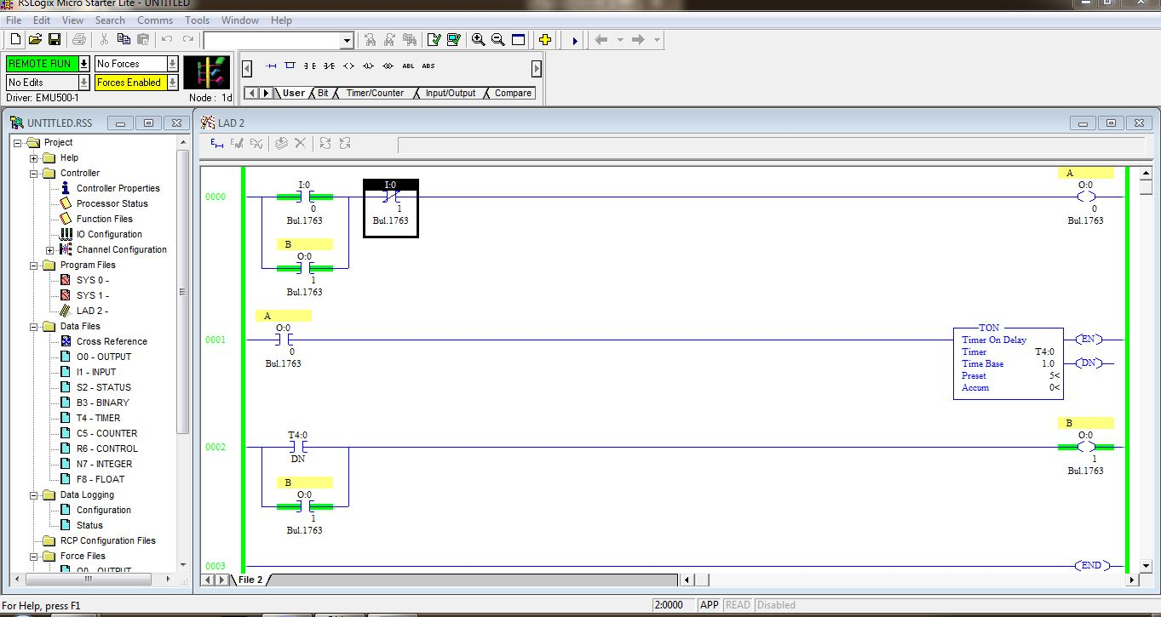

5) Draw a ladder diagram for an agitator-motor system having the following conditions: -

Agitator starts when ‘start’ pb is pressed. After 5 sec pump is started. When the pump is switched off, the agitator also stops. When agitator goes off it cannot start for 3 sec. List out all input and output with their address respectively.

inputs :- 1) start button (I:0.0/0)

2) System stop button (I:0.0/1)

3) stop button (I:0.0/2)

output :- 1) Agitator motor (O:0.0/0)

2) Pump (O:0.0/1)

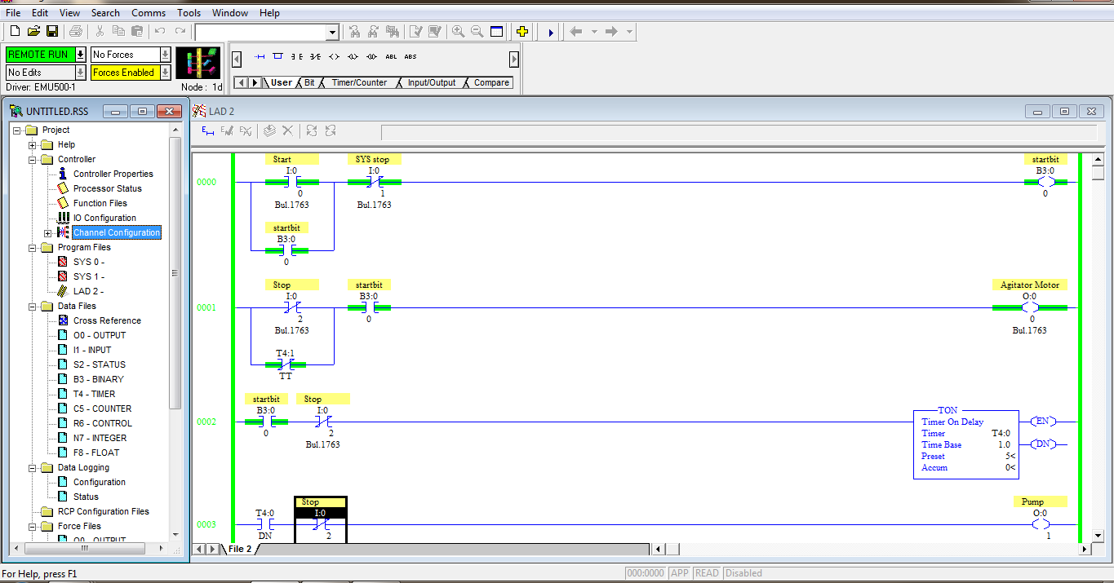

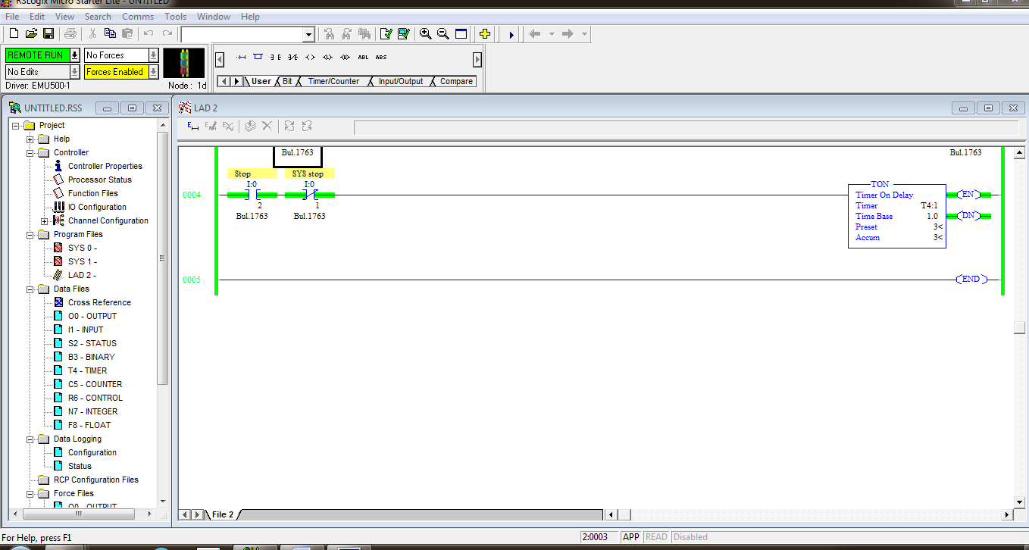

1. Draw a ladder diagram for the problem given below :

When a start button is depressed, M goes on. Five second later, N goes on. When stop is pressed both M & N goes off. In addition, 6.5 seconds after M and N go off, fan F, which had previously been off, goes on. F remains on until the start button is depressed again. List out input and output with their address.

input :- 1) Start push-button (I:0.0/0)

2) Stop push-button(O:0.0/1)

output :- 1) M (O:0.0/0)

2) N (O:0.0/1)

3) Fan (O:0.0/2)

